**Assignment 1: Create and Clone a Repository**

1. **Create a new repository**:
   * Go to **GitHub.com** and click the "+" icon in the top-right corner.
   * Select "**New repository**."

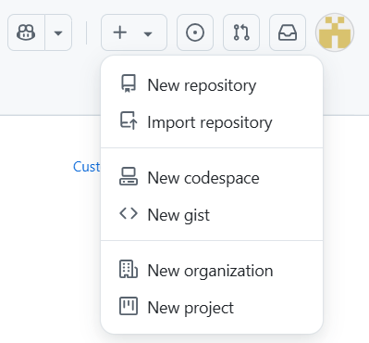

* + Name it **my-first-repo**, add a description, and choose "Public" or "Private."
  + Click "**Create repository**."

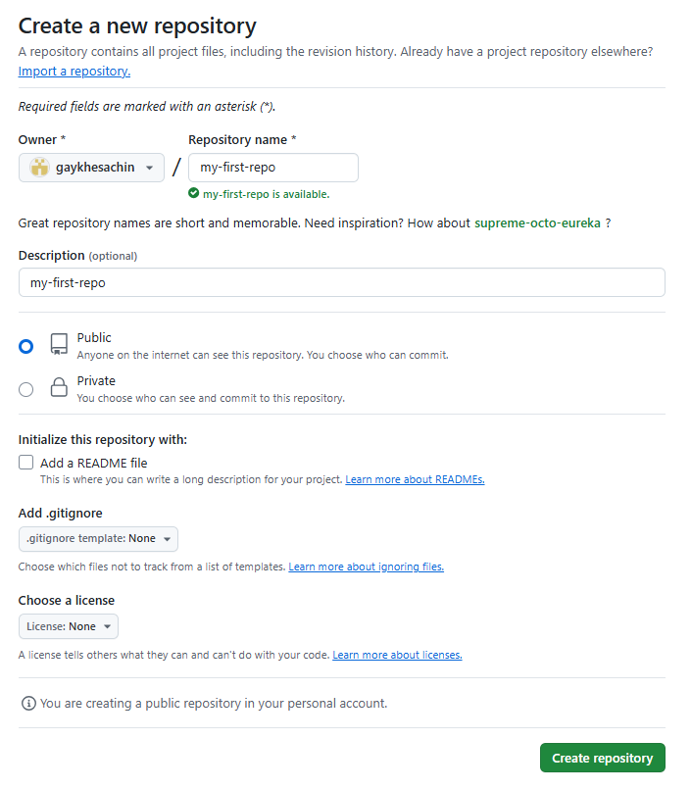

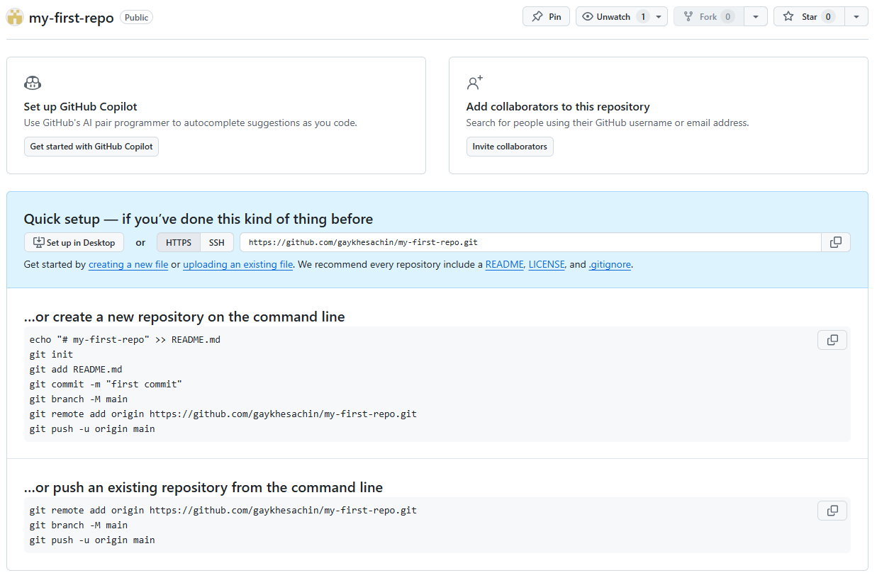

1. **Clone the repository**:
   * Open GitHub Desktop.
   * Click "**File**" > "**Clone Repository**."

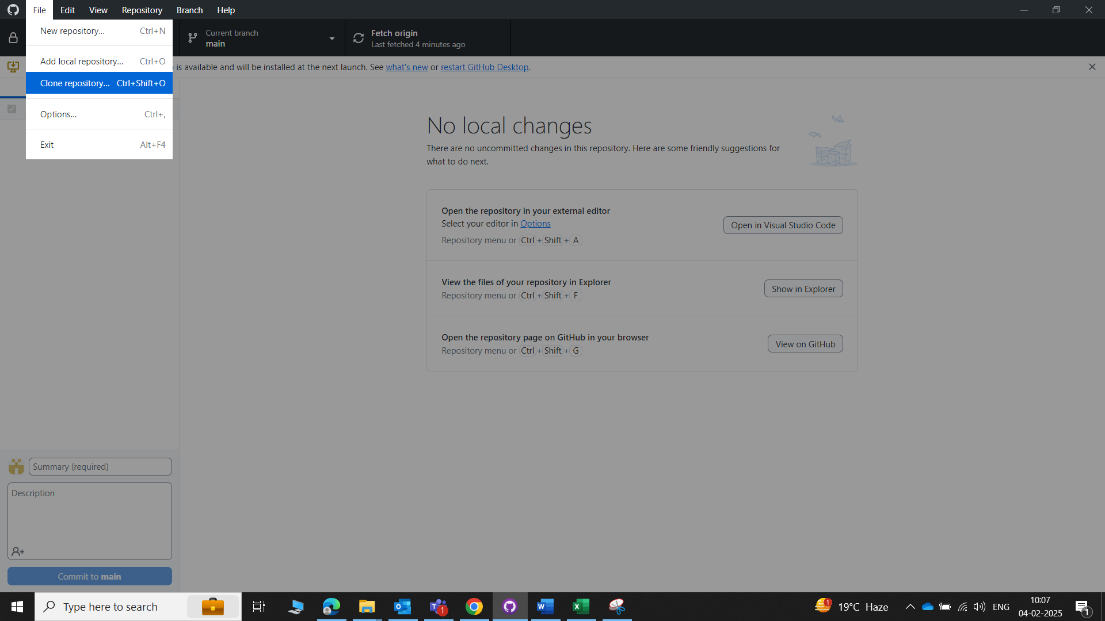

* + Select the **my-first-repo** repository and choose a local path.

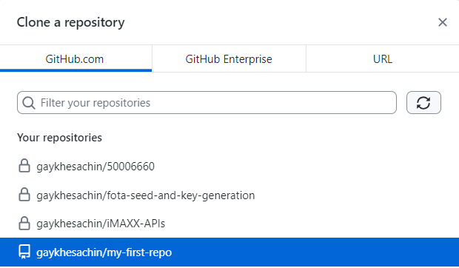

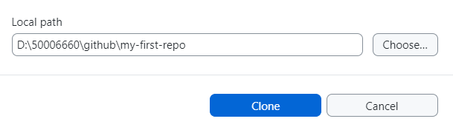

* + Click "**Clone**."

1. **Add a README.md file**:
   * Open the cloned repository folder on your computer.
   * Create a new file named **README.md** and add some text,   
     e.g., # My First Repo.

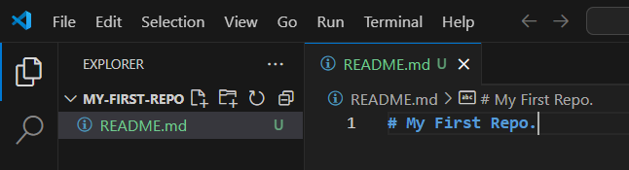

* + **Save** the file.

1. **Commit and push**:
   * In GitHub Desktop, you’ll see the **README.md** file under "**Changes**."  
     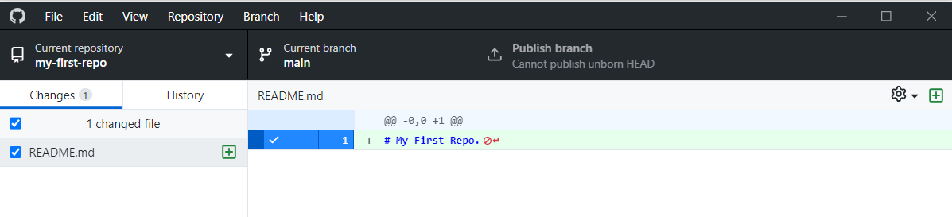
   * Write a **commit message**, e.g., "**Add README.md**."
   * Click "**Commit to main**" and then "**Push origin**."

